
PES UNIVERSITY
(Established under Karnataka Act No. 16 of 2013)
100-ft Ring Road, Bengaluru – 560 085, Karnataka, India

Project Report (Phase-1)

on

Taste of Home

Submitted by
GANDHI NISARG KETAN - PES1PG22CA070

Oct 2023 – Jan 2024

under the guidance of

Ms. Ganga Gudi,
Assistant Professor
Department of Computer Applications,
PESU, Bengaluru – 560085

FACULTY OF ENGINEERING
DEPARTMENT OF COMPUTER APPLICATIONS
PROGRAM – MASTER OF COMPUTER APPLICATIONS

CERTIFICATE

This is to certify that the project entitled

Taste of Home

is a bonafide work carried out by

GANDHI NISARG KETAN – PES1PG22CA070

in partial fulfillment for the completion of Capstone Project, Phase-1 work in the Program of Study MCA under rules and regulations of PES University, Bengaluru during the period Oct. 2023 – Jan 2024. The project report has been approved as it satisfies the academic requirements of 3rd semester MCA.

Internal Guide  Ms. Ganga Gudi, Assistant Professor,  Department of Computer Applications,  PES University, Bengaluru - 560085 |  | Chairperson  Dr. Veena S,  Department of Computer Applications,  PES University, Bengaluru - 560085

DECLARATION

I, Gandhi Nisarg Ketan, bearing PES1PG22CA070 hereby declare that the Capstone project phase-1 entitled, Taste of Home, is an original work done by me under the guidance of Ms. Ganga Gudi, Assistant Professor, PES University, and is being submitted in partial fulfillment of the requirements for completion of 3rd Semester course in the Program of Study MCA. All corrections/suggestions indicated for internal assessment have been incorporated in the report.

PLACE:

DATE:

ABSTRACT

Taste of Home stands as an innovative MERN stack web platform poised to revolutionize the culinary landscape through a dynamic supply-on-demand model. Facilitating connections between passionate local food producers and eager consumers, the platform champions a community-driven approach to food. Users can effortlessly create profiles, designating themselves as talented food producers or enthusiastic consumers. These comprehensive profiles showcase culinary specialties, expertise, and location, fostering a sense of community within the Taste of Home ecosystem. Food producers are empowered to showcase their unique offerings through detailed listings that spotlight their culinary talents and specialties, providing consumers with valuable information. The platform features an integrated messaging system, enabling direct communication between users and producers, facilitating custom instructions, modifications, and seamless interaction. A robust review and rating system enhances transparency and trust within the Taste of Home community, allowing users to provide valuable feedback and enrich the overall user experience. Secure payment gateways are seamlessly incorporated to facilitate smooth transactions, supporting various payment methods such as credit/debit cards and digital wallets. The user dashboard, crafted to be intuitive and user-friendly, caters to both food producers and consumers, including a comprehensive order history feature to enhance overall user experience. Beyond being a platform, Taste of Home has a profound mission to promote local culinary talents, address critical issues like food waste, and contribute significantly to local economies. The vision is to create a thriving ecosystem where the unique talents of local food producers are celebrated, reducing food waste and fostering community connections that positively impact local economies. Through the seamless fusion of digital convenience and the authenticity of homemade food, Taste of Home aspires to be a transformative catalyst in redefining the culinary landscape, promoting sustainability, and reshaping the way people experience and share culinary delights.

TABLE OF CONTENTS
Chapter 1 INTRODUCTION............................................................................................................................ 1
  - PROJECT DESCRIPTION............................................................................................................. 1
Chapter 2 LITERATURE SURVEY ................................................................................................................4
2.1 DOMAIN SURVEY .......................................................................................................................4
2.2 RELATED WORK .........................................................................................................................4
2.3 EXISTING SYSTEMS ..................................................................................................................8
2.4 TECHNOLOGY SURVEY............................................................................................................8
Chapter 3 HARDWARE AND SOFTWARE REQUIREMENTS..................................................................9
3.1 HARDWARE REQUIREMENTS.................................................................................................9
3.2 SOFTWARE REQUIREMENTS .................................................................................................9
Chapter 4 SOFTWARE REQUIREMENTS SPECIFICATION.....................................................................10
4.1 USERS ..........................................................................................................................................10
4.2 FUNCTIONAL REQUIREMENTS .............................................................................................10
4.3 NON-FUNCTIONAL REQUIREMENTS ...................................................................................10
Chapter 5 SYSTEM DESIGN ........................................................................................................................11
5.1 ARCHITECTURE DIAGRAM ....................................................................................................11
Chapter 6 DETAILED DESIGN .....................................................................................................................12
6.1 CLASS DIAGRAM ......................................................................................................................12
6.2 USE CASE DIAGRAM.................................................................................................................14
6.3 ACTIVITY DIAGRAM.................................................................................................................16
6.4 DATABASE DESIGN...................................................................................................................22
Chapter 7 IMPLEMENTATION ....................................................................................................................25
7.1 SCREEN SHOTS..........................................................................................................................25
REFERENCES ...............................................................................................................................................29

INTRODUCTION

  - PROJECT DESCRIPTION

Taste of Home is an innovative online platform designed to connect local food producers with consumers, creating a vibrant and supportive community around culinary delights. This MERN stack web application facilitates seamless interactions through user profiles, allowing talented food producers and enthusiastic consumers to showcase their specialties, expertise, and locations. Food producers can list their unique offerings, providing consumers with valuable insights into their culinary talents. The platform incorporates an integrated messaging system for direct communication, a robust review and rating system for transparency, and secure payment gateways to ensure smooth transactions. With a user-friendly dashboard featuring comprehensive order history, Taste of Home not only enhances the overall user experience but also contributes to building robust local economies and reducing food waste. Join us in celebrating local flavors, fostering community connections, and redefining the way we experience and share homemade culinary delights.

  - PROBLEM DEFINITION

The current challenge in the culinary landscape lies in the fragmented connection between local food producers and consumers. Some of the common problems faced by food producers and consumers include:
- Limited Connectivity.
- Underutilized Culinary Talent.
- Food waste in Traditional Supply Chain.
Addressing these issues is crucial for fostering stronger connections within the culinary community and promoting a more sustainable and efficient food supply chain.

  - PROPOSED SOLUTION

The proposed solution is to develop a web application that addresses the challenges faced by food producers and consumers in the culinary landscape. This application will provide the following features:
- Digital Bridge & Connectivity:
  - Comprehensive digital platform serving as a bridge between local food producers and consumers.
- Supply-on-Demand Model:
  - Introduces a supply-on-demand model, allowing producers to meet consumer demand more efficiently.

  - PURPOSE

The purpose of the Taste of Home Web application is to streamline the process of ordering home-cooked food, providing users with a convenient and user-friendly platform. Upon logging in, users can effortlessly browse a variety of culinary offerings, place orders, and make secure payments through various methods such as credit/debit cards and digital wallets. The integrated messaging system enables direct communication between users and food producers, allowing for custom instructions and a personalized experience. Furthermore, users can share their feedback and experiences by reviewing the food they've enjoyed, fostering a sense of community and trust within the Taste of Home platform. This project aims to bring the authentic taste of homemade food closer to users while creating a seamless and enjoyable experience from order to delivery.

  - SCOPE

Taste of Home web application is dedicated to building a vibrant ecosystem that celebrates and promotes local culinary talents. Beyond simplifying food ordering, it actively addresses issues like food waste by connecting consumers with local producers. This initiative supports local economies, creating a positive impact on both food producers and regional communities. Join us in celebrating local flavors while contributing to a more sustainable and community-centric food ecosystem.

2. LITERATURE SURVEY

2.1 DOMAIN SURVEY
This project falls under the domain, Local and Home made Food Ordering.
Existing Applications:
- Swiggy: An online food delivery platform connecting users with local restaurants for doorstep delivery.
- Zomato: A global restaurant discovery and food delivery platform offering restaurant exploration, reviews, and food ordering services.
- Uber Eats: A food delivery platform proving users to order food from local restaurants and having it delivered by Uber drivers.
Limitations:
- Only restaurants can register on these platforms.
- Lack of direct communication between users and food producers via messaging.

2.2 RELATED WORK

    - A Real Time Web Service System for Food Delivery
Authors: Kartik, Ishika Bansal, Kirti, Kartik Rajvanshi
Date: 2023
Publisher: Journal of Data Acquisition and Processing
Summary:
- The research paper focuses on developing a real-time web service system for food delivery to provide fresh, hygienic, and affordable meals to customers living away from home.
- The paper discusses the need for nutritious and healthy food options for individuals studying or working outside their homes and the challenges they face in obtaining such meals.
- The authors propose a web service that aims to offer quality food, reasonable prices, and a variety of tastes while also providing employment opportunities for housewives. The system includes features such as database design, user interface, payment methods, order tracking, and process diagrams.

    - Causal analysis of factors contributing to food wastage in restaurants of India
Authors: Mahakpreet Kaur Virdi, Shubhangi Gupta, Nitasha Hasteer, Kashish Rastogi
Date: 2023-12-27
Publisher: International Conference on Computational Intelligence and Sustainable Engineering Solutions (CISES)
Summary:
- The research paper investigates the factors contributing to food wastage in restaurants in India.
- The study uses a survey analysis to identify six factors causing food wastage and applies the DEMATEL (Decision-Making Trial and Evaluation Laboratory) approach to establish causal relationships.
- The most influential factor identified is "Less Shelf Life (LSL)." The paper emphasizes the importance of reducing food waste for social, economic, and environmental reasons.

2.2.3 Food Ordering website "Cooked with care" developed using MERN stack
Author :- Amit Shersingh Chauhan, Abhishek Mishra, Sushil Bhardwaj, Sunita Nandgave
Date: 2022
Publisher: IEEE Xplore
Summary:
- The research paper presents the development of a food ordering website called "Cooked with care" using the MERN stack (MongoDB, ExpressJS, React, NodeJS) and other technologies such as AWS cloud storage.
- The website aims to provide a digital platform for homemakers and restaurant owners to sell their products and services online, with customer feedback and the ability to update menus.
- The paper discusses the design and implementation of the website, its features including customer payment gateway, order management, and generating bills and invoices, and highlights its potential to reduce food wastage and enhance convenience for consumers and business owners.

    - Web Based Application for Ordering Food Raw Materials
Authors: Rita Layona, Budi Yulianto, Yovita Tunardi
Date: 2021
Publisher: 1st International Conference on Computer Science and Artificial Intelligence
Summary:
- The research paper addresses the economic impact of the Covid-19 pandemic in Indonesia, specifically focusing on the challenges faced by housewives in shopping for food raw materials while avoiding virus transmission.
- The authors propose a web-based application that allows housewives and community members to safely and easily order food raw materials from local merchants, with delivery carried out by a local government courier.
- The study utilizes a mixed method approach, combining quantitative research and the Waterfall development method, to gather requirements and develop the application. The paper highlights the importance of centralized goods delivery and the use of Indonesian language for local residents.

2.2.5 Design of Web App for Online Food Services
Authors: Harsh Pathak, Naman Gupta, Dhiren Premakar, Preeti Garg
Date: May 2022
Publisher: International Journal for Research in Applied Science & Engineering Technology (IJRASET)
Summary
- The research paper discusses the design of a web application for online food services, emphasizing the convenience and benefits of online food ordering.
- The proposed methodology involves a requirement analysis stage, the development of a mobile food ordering system, and the use of the MERN stack technology.
- The paper highlights the features and advantages of an online food ordering system, such as easy access to information, customer support, and potential cost savings for restaurants. It also acknowledges potential disadvantages, including quality control and delivery challenges.

  - EXISTING SYSTEMS
Swiggy: Swiggy is an online food delivery platform that connects users with a wide range of local restaurants, allowing them to order food and have it delivered to their doorstep.
Zomato: Zomato is a global restaurant discovery and food delivery platform that enables users to explore restaurants, read reviews, and order food for delivery or takeout.
Uber Eats: Uber Eats is the food delivery arm of Uber, providing users with the convenience of ordering food from local restaurants through the Uber Eats app and having it delivered by Uber drivers.

  - TECHNOLOGY SURVEY
React: React is a JavaScript library for building user interfaces, known for its declarative and efficient approach to creating interactive components.
Express.js: Express.js is a minimal and flexible Node.js web application framework that simplifies the process of building robust web applications.
Node JS: Node.js is a server-side JavaScript runtime that allows for building scalable and high-performance applications.
Cloudinary (for images): Cloudinary is a cloud-based image and video management service, offering features like storage, optimization, and delivery for media assets.
MongoDB: MongoDB is a NoSQL database management system, ideal for handling unstructured data and scalable applications.
Stripe (for payment): Stripe is a secure and developer-friendly platform that provides tools for online payment processing, supporting credit/debit card and digital wallet transactions.

3. HARDWARE AND SOFTWARE REQUIREMENTS

3.1 HARDWARE REQUIREMENTS
- Processor : Intel i3 and above
- Ram : Minimum 4 GB
- Hard Disk : Minimum 10 GB

3.2 SOFTWARE REQUIREMENTS
- Operating System : Windows or Linux
- Frontend Tool : ReactJS (v18.2.0 or higher)
- Backend Tool : NodeJS(v18.16.0 or higher)
- Database : MongoDB (v5.0.2 or higher)
- Web Browser : Google Chrome, Microsoft Edge, Brave, Safari, etc.
- Development Tool : Visual Studio Code
- API Testing Tool : Postman

4. SOFTWARE REQUIREMENTS SPECIFICATION
4.1 USERS
- Guest
- Consumer
- Food Producer

4.2 FUNCTIONAL REQUIREMENTS
User Profiles :
- Creation of profiles for food producers and consumers.
Listings :
- Producers can showcase offerings of food items with detailed information.
Messaging :
- Users engage in direct communication with producers.
Reviews and Ratings :
- Robust system for transparency and trust.
Payment Integration :
- Secure transactions supporting various methods.

4.3 NON-FUNCTIONAL REQUIREMENTS
Performance :
- The platform should have low latency and fast response times, ensuring a smooth and efficient user experience even during peak usage periods.
Scalability :
- Design the system to be scalable, allowing it to handle a growing number of users, listings of item and transactions without compromising performance.
Security :
- Implement robust encryption and authentication to safeguard user data.

5. SYSTEM DESIGN
5.1 ARCHITECTURE DIAGRAM
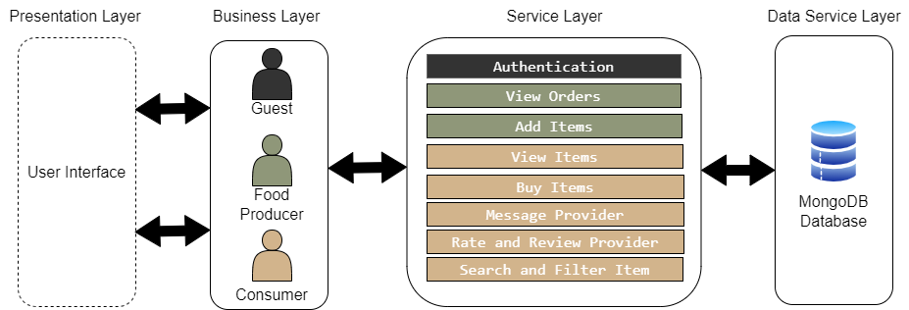
Fig. 5.1. Architecture Diagram

Presentation Layer : This is the topmost layer which is responsible for managing the user interface, facilitating the interaction between user and system.
Business Layer : This layer oversees the interaction between guest, food producer and consumer within the system.
Service Layer : This layer lists various services that the user can interact with. These services include authentication, order viewing, item addition, item viewing, item purchase, messaging, provider rating and reviewing, as well as item searching and filtering.
Data Service Layer : This is the bottom layer, represented by MongoDB. MongoDB is used to store data related to users, food items, chats and reviews.

6. DETAILED DESIGN
6.1 CLASS DIAGRAM
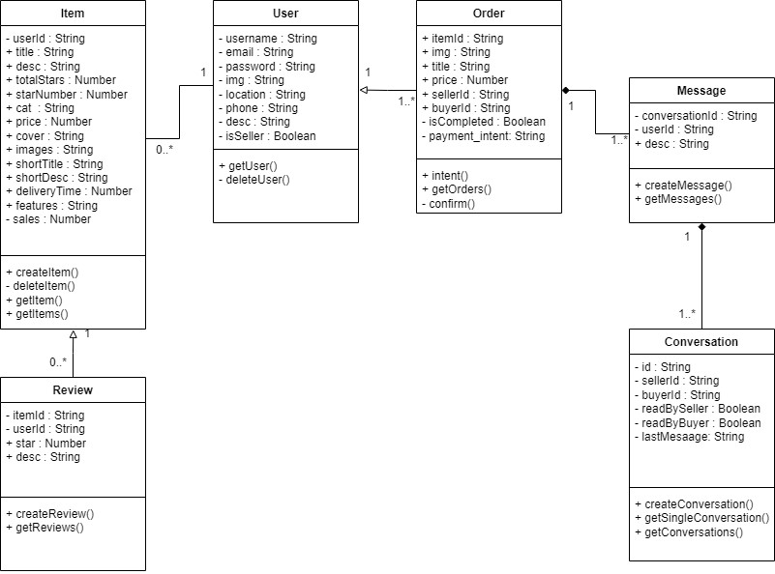

Fig. 6.1. Class Diagram
User : This class has attributes like username (string), email (string), password (string), img (string), location (string), phone (string), desc (string), isSeller (boolean). It has methods like getUser(), deleteUser().
Item : This class has attributes like userId (string), title (string), desc(string), totalStars (number) ,starNumber (number), cat (string), price(number), cover (string), images (string), shortTitle (string), shortDesc (string), deilveryTime (number), features (string), sales (number). It has methods like createItem(), deleteItem(), getItem(), getItems().
Order : This class has attributes like itemId (string), img (string), title (string), price (number), sellerId (string), buyerId (string), isCompleted (Boolean), payment_intent (string). It has methods like intent(), getOrders(), Confirm().
Message : This class has attributes like conversationId (string), userId (string), desc (string). It has methods like createMessage(), getMessages().
Conversation : This class has attributes like id (string), sellerId (string), buyerId (string), readBySeller : (Boolean), readByBuyer (Boolean), lastMessage (string). It has methods like createConversation(), getSingleConversation(), getConversations().
Review : This class has attributes like itemId (string), userId (string), star (number), desc (string). It has methods like createReview(), getReviews().

6.2 USE CASE DIAGRAM
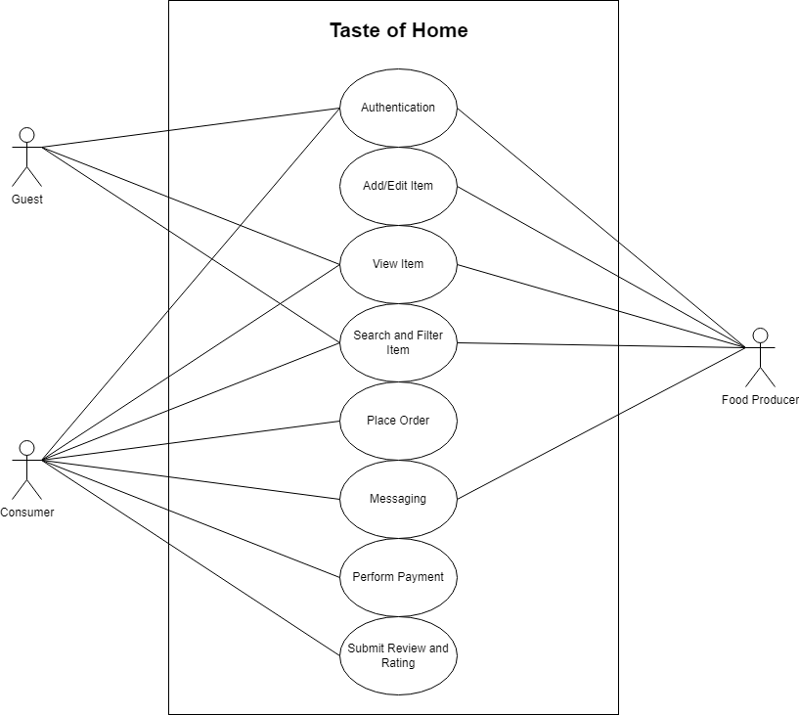
Fig. 6.2. Use Case Diagram
Actors : There are three actors in this diagram – Guest, Consumer and Food Producer.
Authentication : Guest, Consumer and Food Producer can authenticate on the website.
Add/Edit Item : Food Producer can add or edit item in listing.
View Item : Guest, Consumer and Food Producer can view item.
Search and Filter Item : Guest, Consumer and Food Producer can search for specific item.
Place order : Consumer can place order.
Messaging : Consumer and Food Producer can message with each other.
Perform Payment : Consumer can make payments
Submit Review and Ratings : Consumer can provide feedback on food item.

6.3.1 ACTIVITY DIAGRAM - GUEST
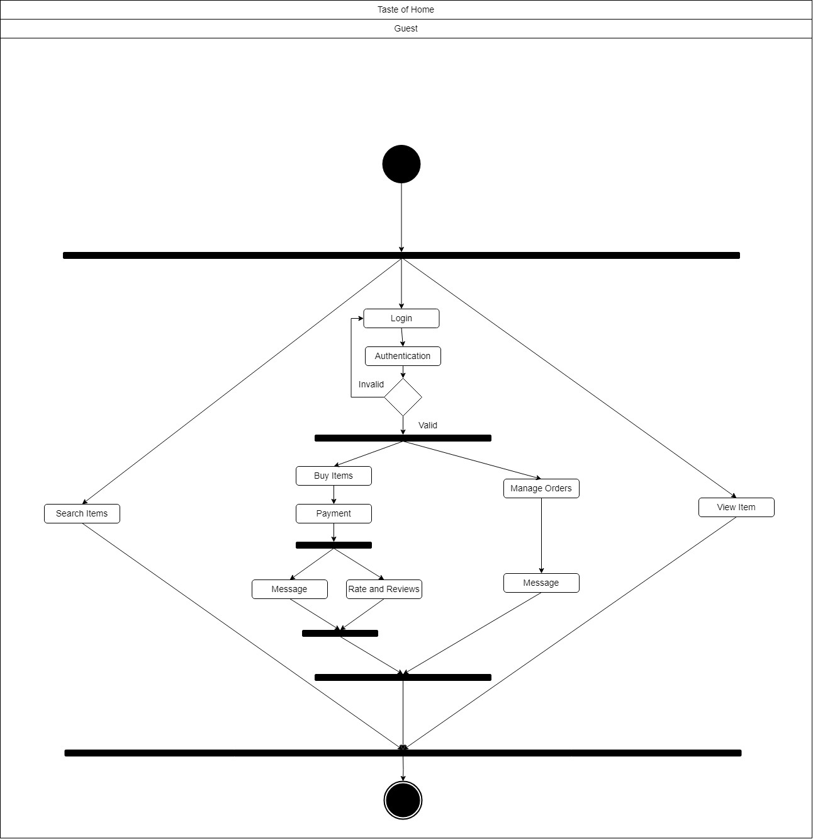

Fig 6.3.1 Activity Diagram - Guest
The activity diagram illustrates the user interaction flow within the application. Starting as a guest, the activity begins with the user having three primary options: searching for items, viewing items, or logging in. If the user opts for login, a valid authentication is necessary for further actions.
Upon successful login, the user is presented with two distinct paths. One path enables the user to manage orders and engage in messaging with food producers. The alternative path allows the user to proceed with buying items, make payments, and post-payment, the user has the option to either send a message or provide a rating and review.
This structured activity flow captures the various paths a user can take based on their initial status as a guest and subsequent choices within the application.
6.3.2 ACTIVITY DIAGRAM – CONSUMER
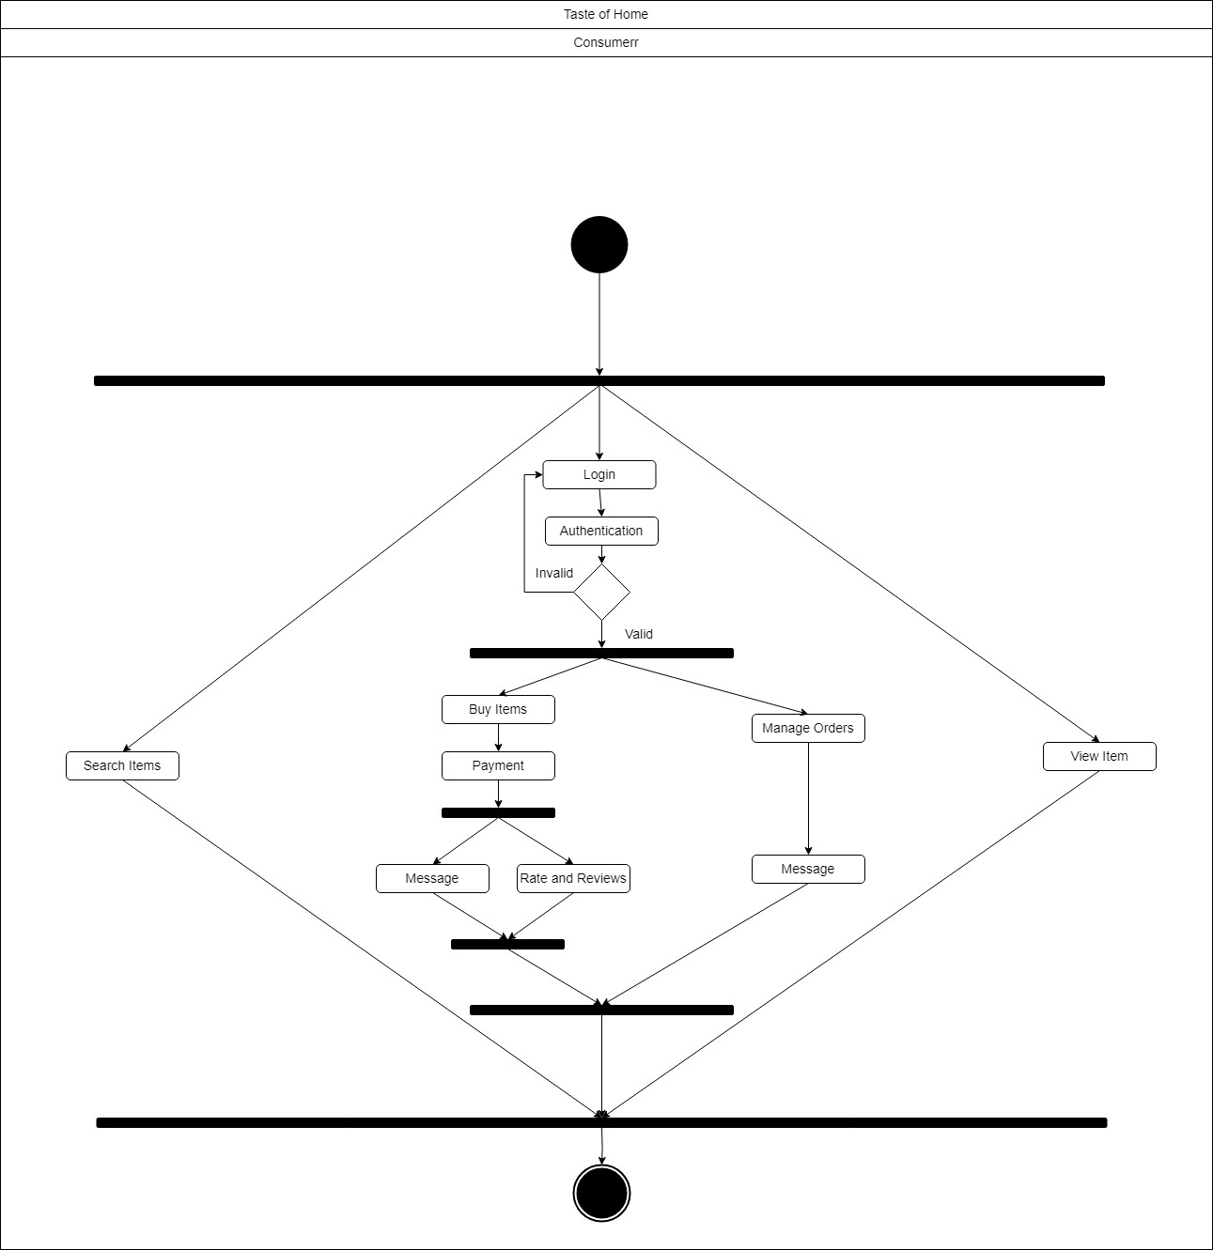
Fig 6.3.2 Activity Diagram – Consumer
The activity diagram illustrates the user interaction flow within the application. Starting as a consumer, the activity begins with the user having three primary options: searching for items, viewing items, or logging in. If the user opts for login, a valid authentication is necessary for further actions.
Upon successful login, the user is presented with two distinct paths. One path enables the user to manage orders and engage in messaging with food producers. The alternative path allows the user to proceed with buying items, make payments, and post-payment, the user has the option to either send a message or provide a rating and review.
This structured activity flow captures the various paths a user can take based on their initial status as a consumer and subsequent choices within the application.

6.3.3 ACTIVITY DIAGRAM – FOOD PRODUCER
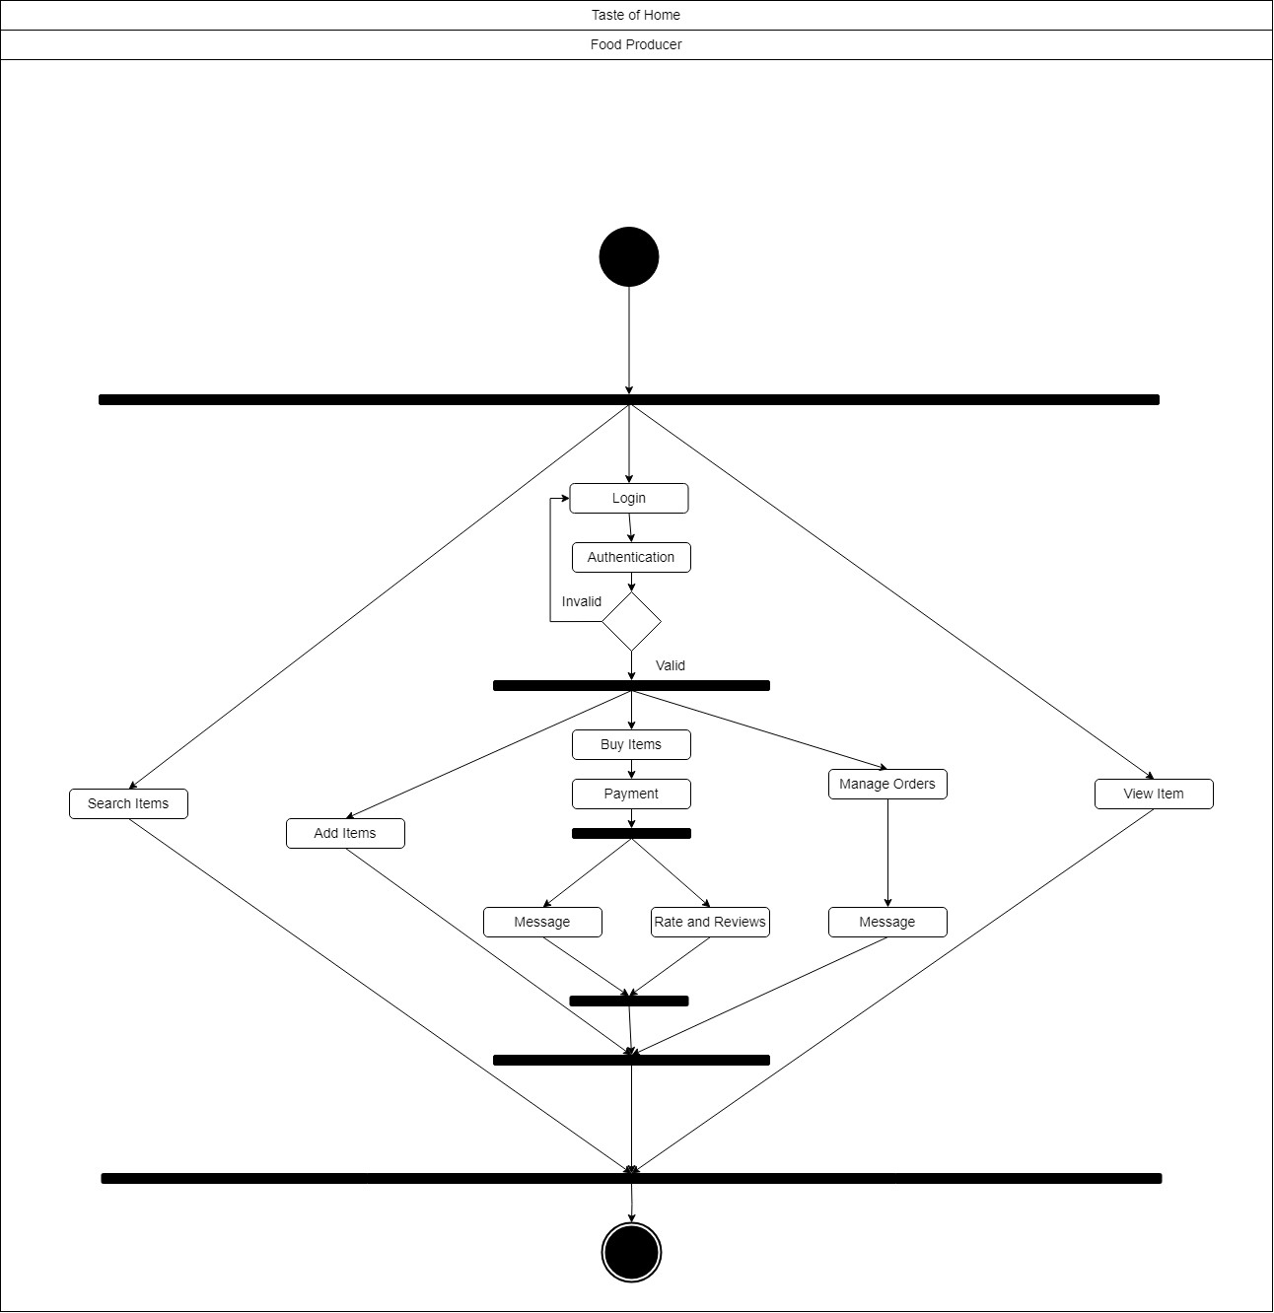
Fig 6.3.3 Activity Diagram – Food Producer

The food producer interface provides three primary options:
- Search Item: Enables food producer to search for specific items within the platform.
- View Item: Allows food producer to preview details and information about a selected item.
- Login: Grants access to additional features. Once logged in, food producer are presented with three more options:
  - Add Item: Facilitates the addition of new items to the platform.
  - Manage Orders: Offers tools to oversee user's order history.
  - Buy Items: Initiates the purchasing process. Following a successful purchase, users encounter two post-purchase options:
    - Message: Allows users to communicate with relevant user.
    - Rate and Review: Users share their feedback and experiences by assigning ratings and leaving reviews.

6.4 DATABASE DESIGN
6.4.1 DOCUMENT STRUCTURE (USER)
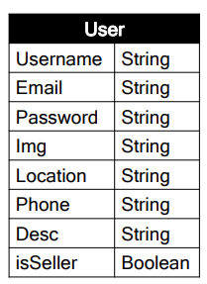
Fig 6.4.1 Document Structure (User)

6.4.2 DOCUMENT STRUCTURE (ITEM)
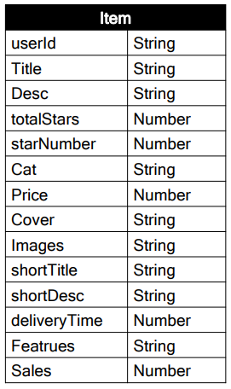
Fig 6.4.2 Document Structure (Item)

6.4.3 DOCUMENT STRUCTURE (ORDER)
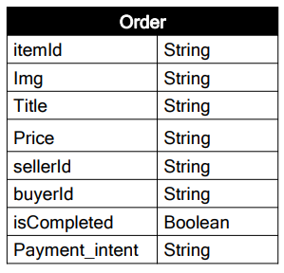
Fig 6.4.3 Document Structure (Order)

6.4.4 DOCUMENT STRUCTURE (REVIEW)
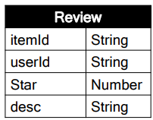
Fig 6.4.4 Document Structure (Review)

6.4.5 DOCUMENT STRUCTURE (CONVERSATION)
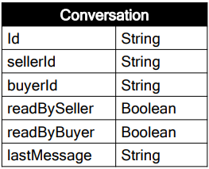
Fig 6.4.5 Document Structure (Conversation)

6.4.6 DOCUMENT STRUCTURE (MESSAGE)
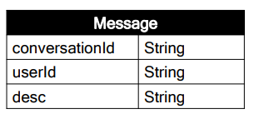
Fig 6.4.6 Document Structure (Message)

7. IMPLEMENTATION
7.1 SCREENSHOTS (HOME)
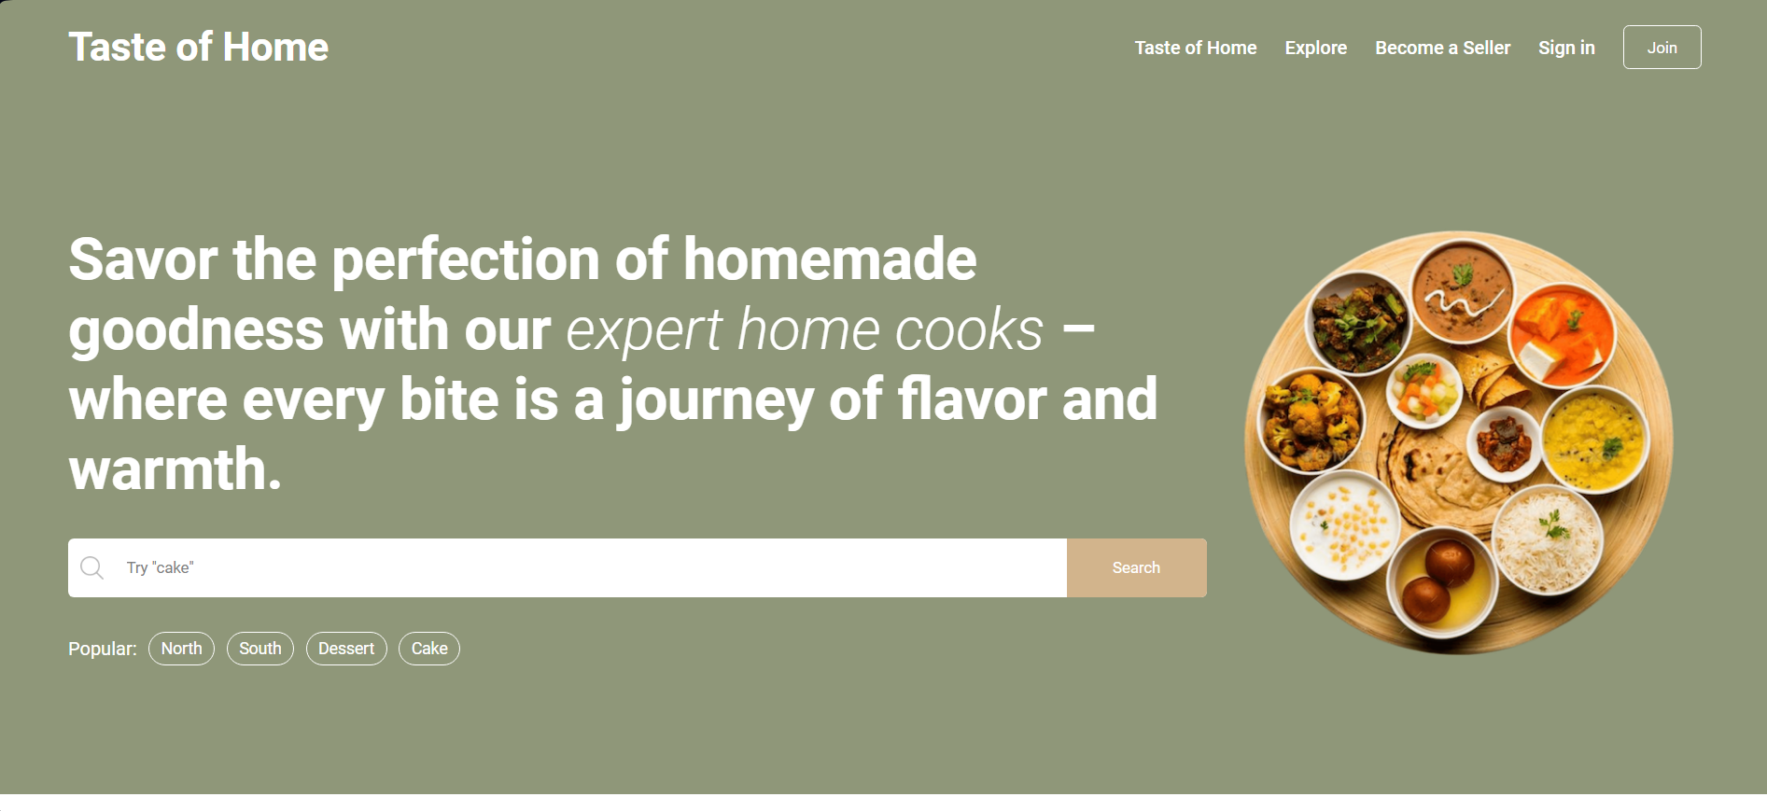
Fig 7.1 Home Page
7.2 SCREENSHOTS (EXPLORE)
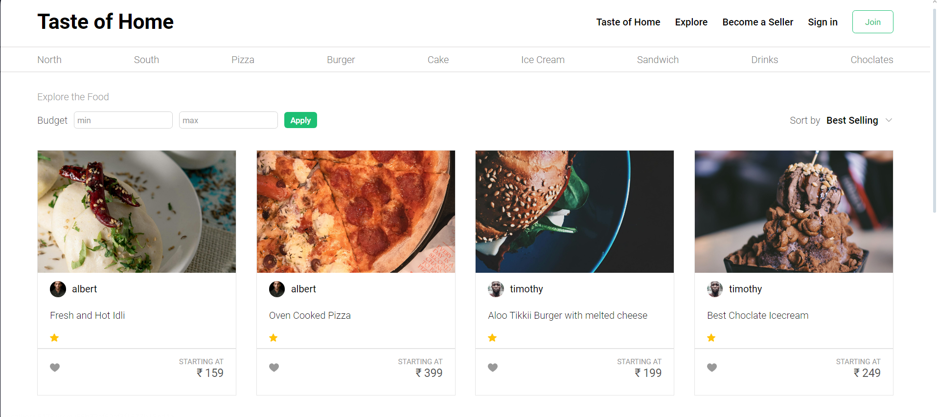
Fig 7.2 Explore Page
7.3 SCREENSHOTS (ITEM)
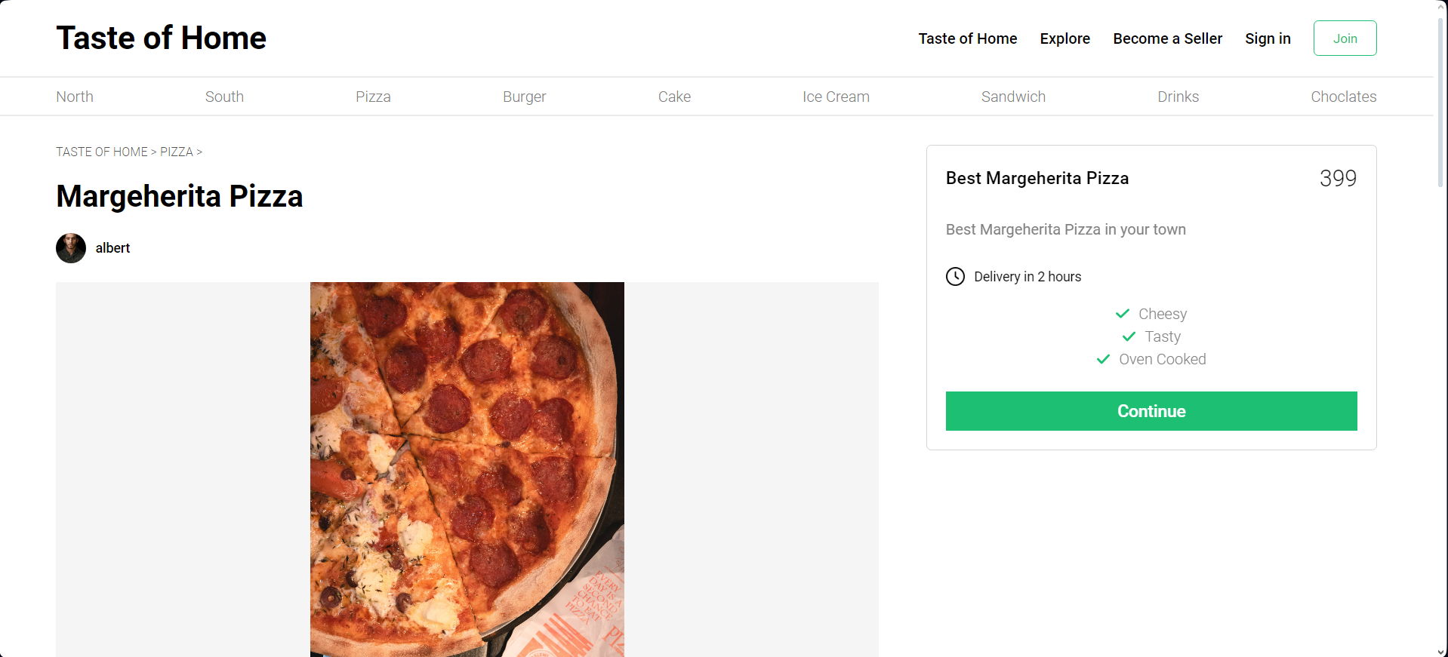
Fig 7.3 Item Page
7.4 SCREENSHOTS (REGISTER)
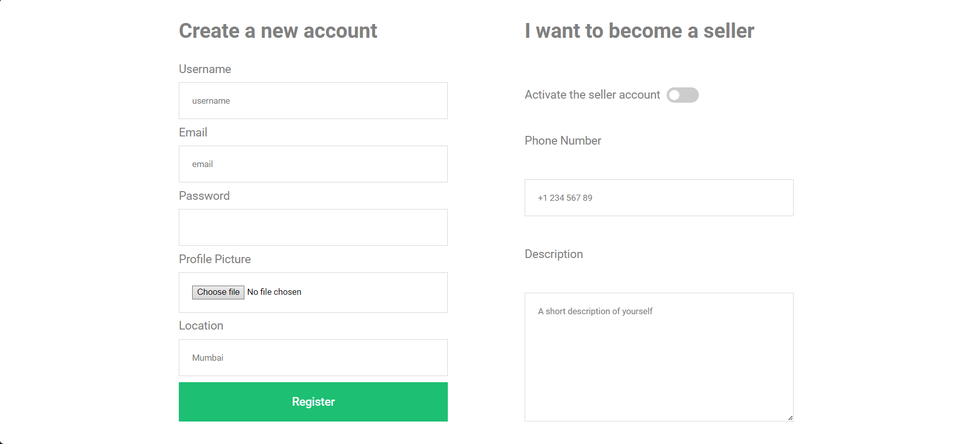
Fig 7.4 Register Page
7.5 SCREENSHOTS (LOGIN)
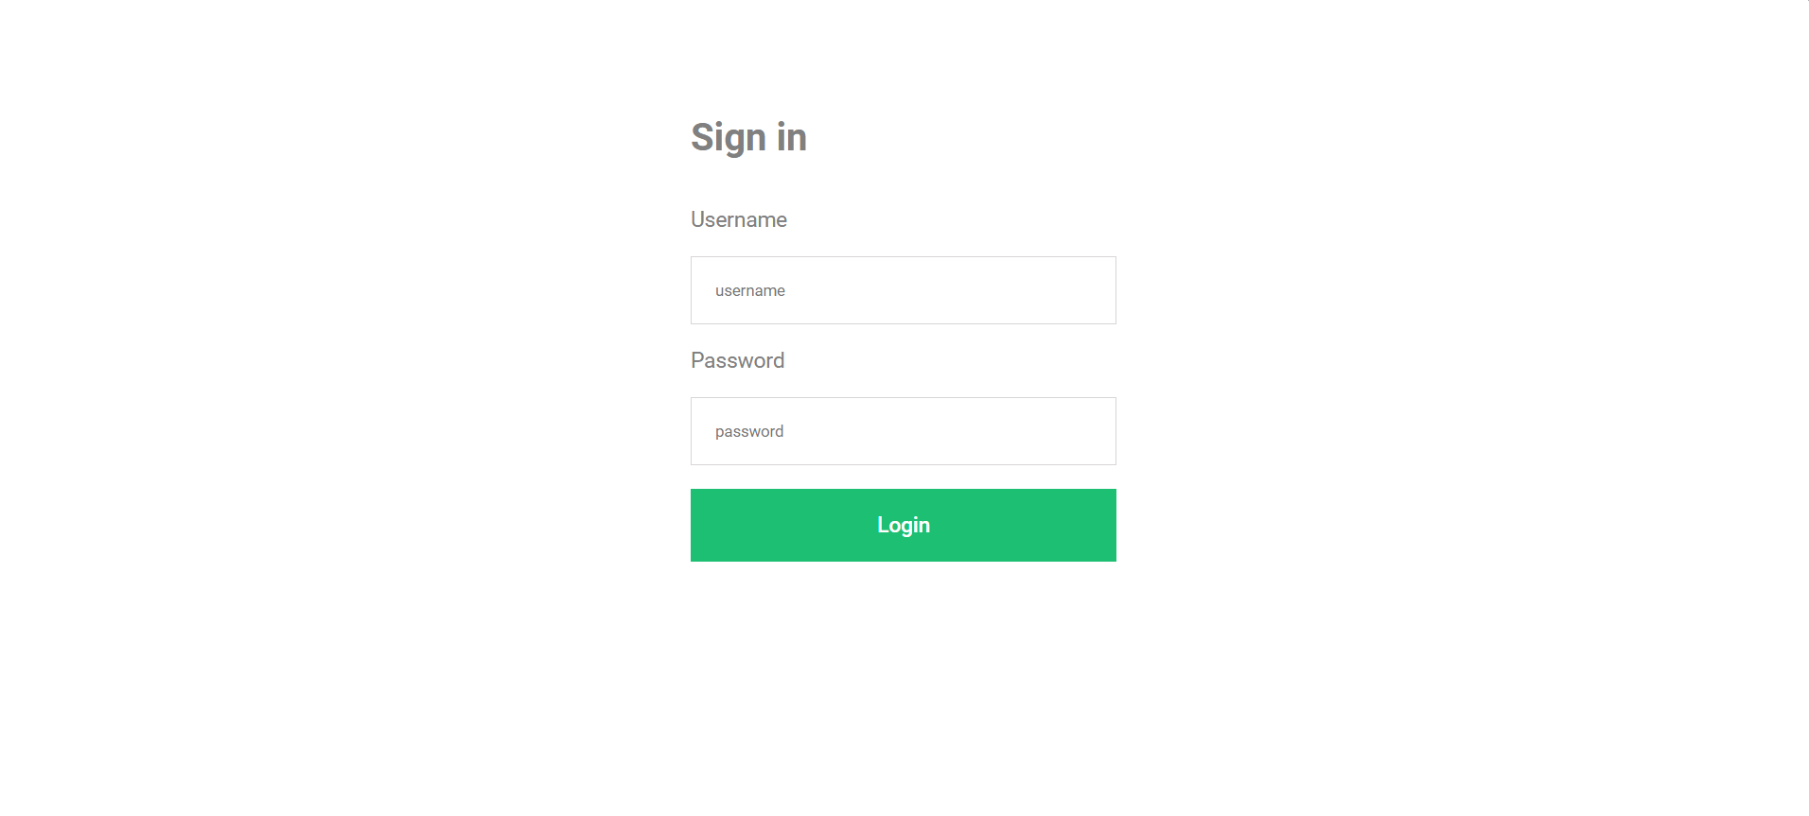
Fig 7.5 Login Page
7.6 SCREENSHOTS (ORDERS)
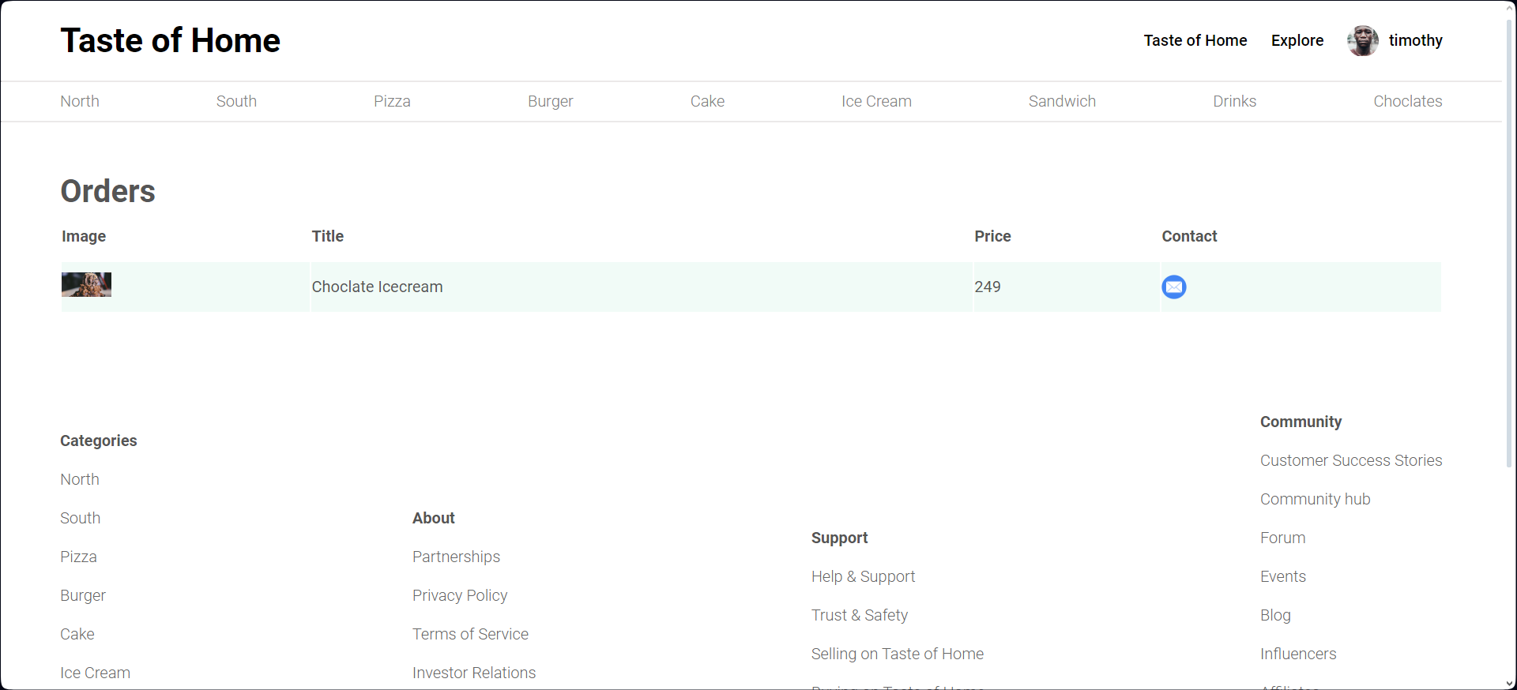
Fig 7.6 Orders Page
7.7 SCREENSHOTS (ADD NEW ITEM)
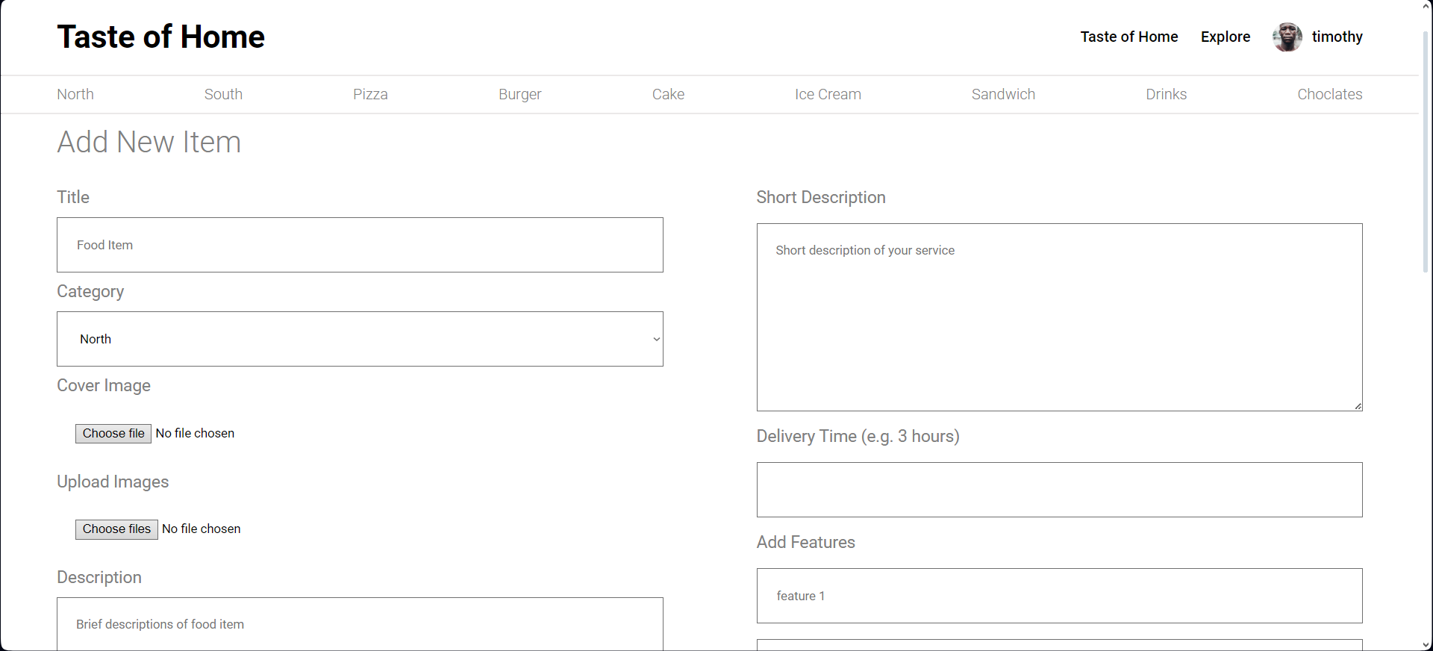
Fig 7.6 Add new item page

APPENDIX A
BIBILOGRAPHY
[1] A REAL TIME WEB SERVICE SYSTEM FOR FOOD DELIVERY | Journal of Data Acquisition and Processing | 2023 | https://sjcjycl.cn/article/view-2023/pdf/02_1628.pdf

[2] Causal analysis of factors contributing to food wastage in restaurants of India | International Conference on Computational Intelligence and Sustainable Engineering Solutions (CISES) | 2023-12-27 | https://ieeexplore.ieee.org/document/10183615

[3] Food Ordering website "Cooked with care" developed using MERN stack | IEEE Xplore | 2022 | https://www.researchgate.net/publication/361178168_Food_Ordering_website_Cooked_with_care_developed_using_MERN_stack

[4] Web Based Application for Ordering Food Raw Materials | 1st International Conference on Computer Science and Artificial Intelligence | 2021 | https://ieeexplore.ieee.org/document/9609733

[5] Design of Web App for Online Food Services | International Journal for Research in Applied Science & Engineering Technology (IJRASET) | May 2022 | https://www.ijraset.com/research-paper/design-of-web-app-for-online-food-services

